DBS 211NII Project

Name: Stephen Suresh

Student ID: 117916213

Group 12:

Ryan Locke (ID: 034748129)

Chung On Tse (ID: 154928188)

Stephen Suresh (ID: 117916213)

Employee Tables

Card functions (Chung On Tse ID: 154928188)

Customer Functions (Ryan Locke ID: 034748129):

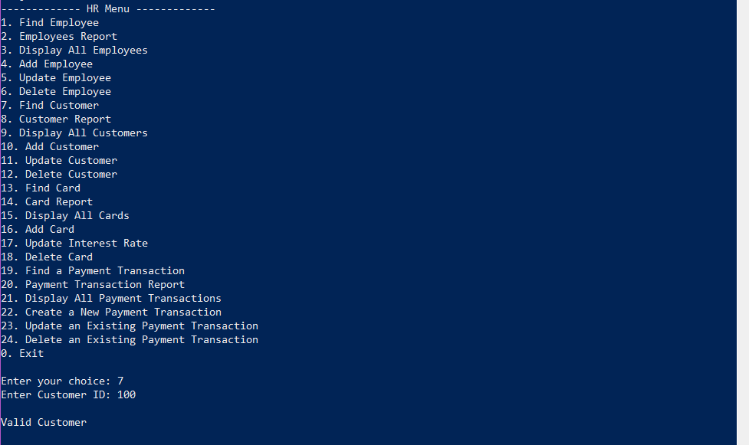

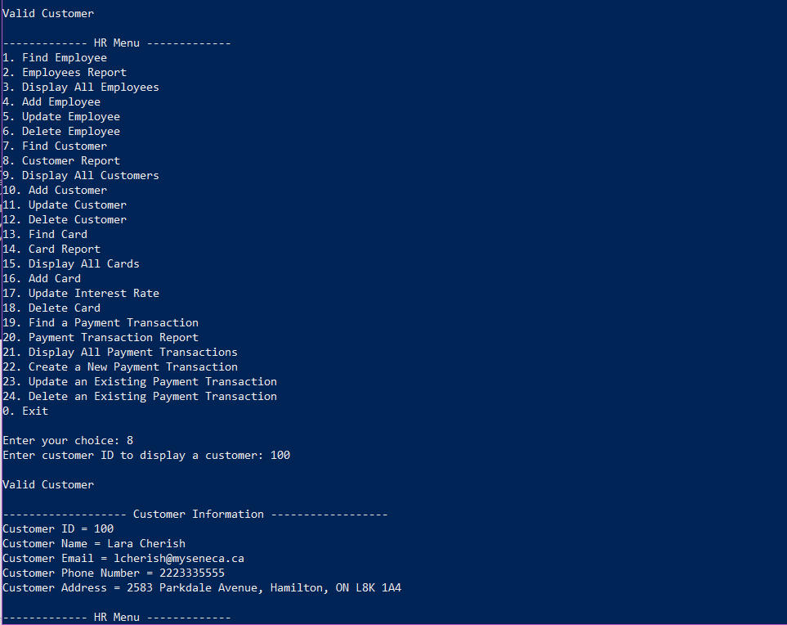

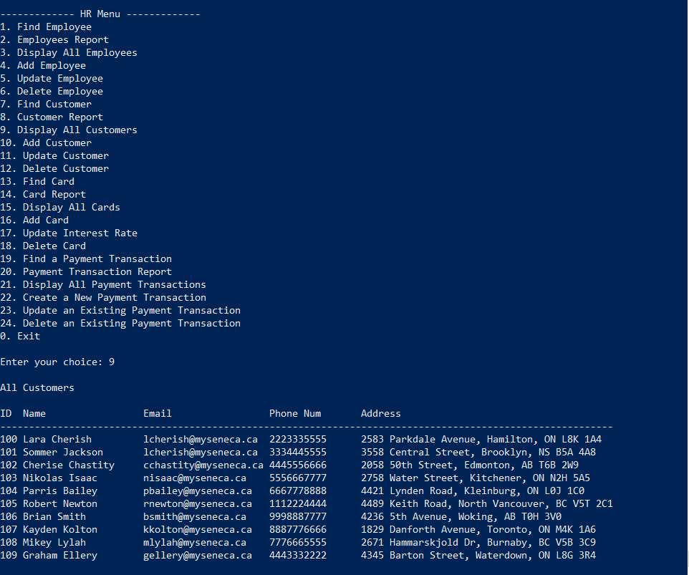

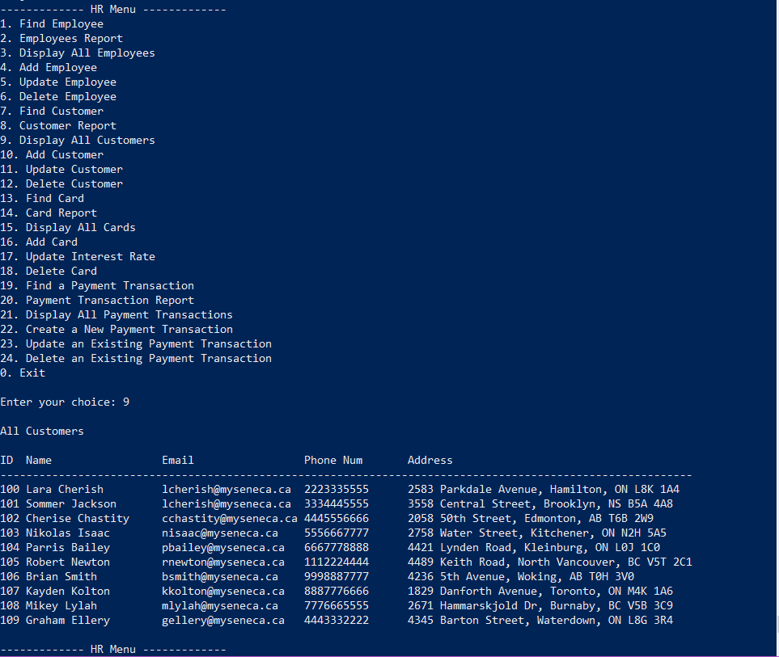

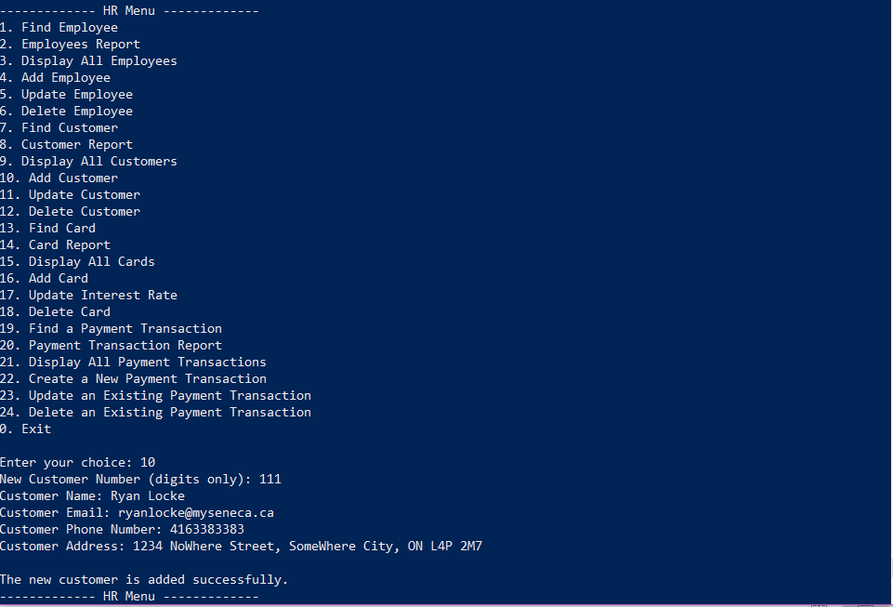

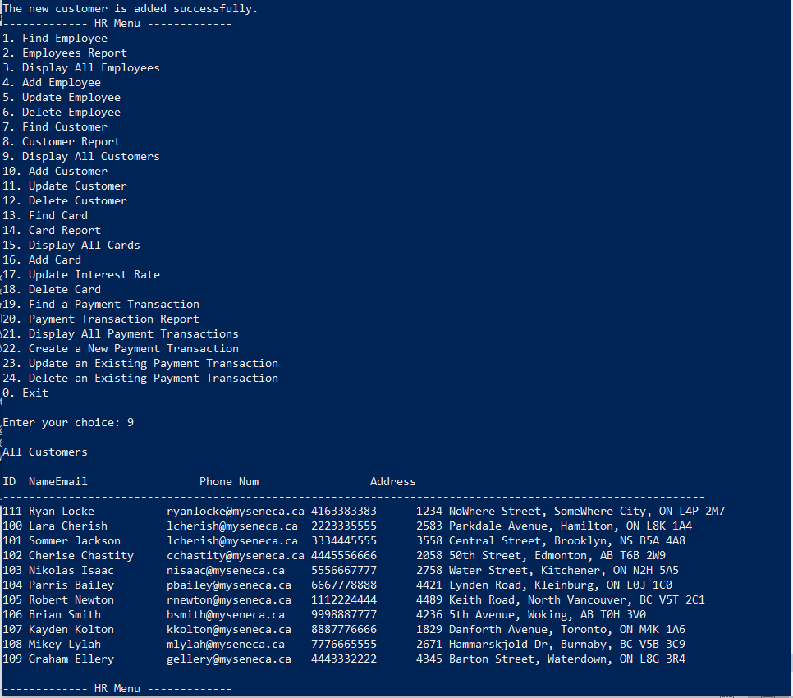

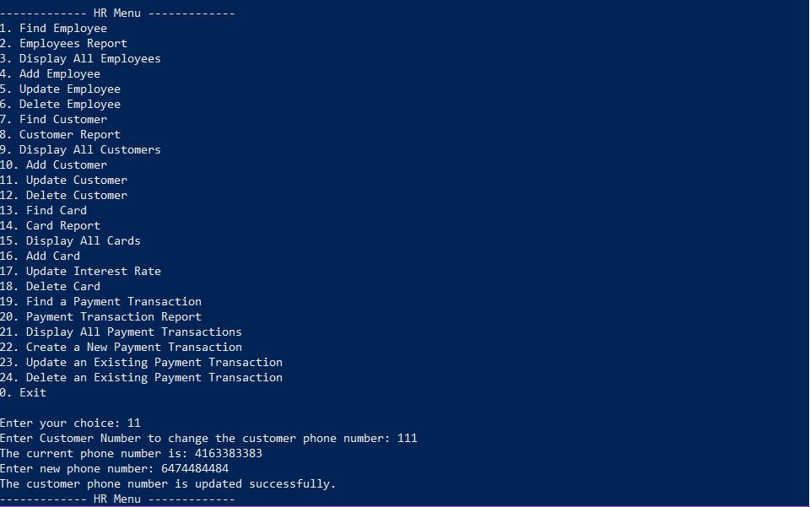

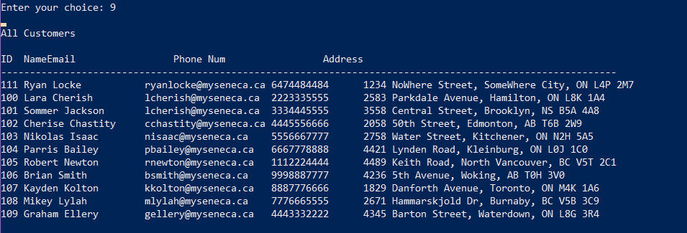



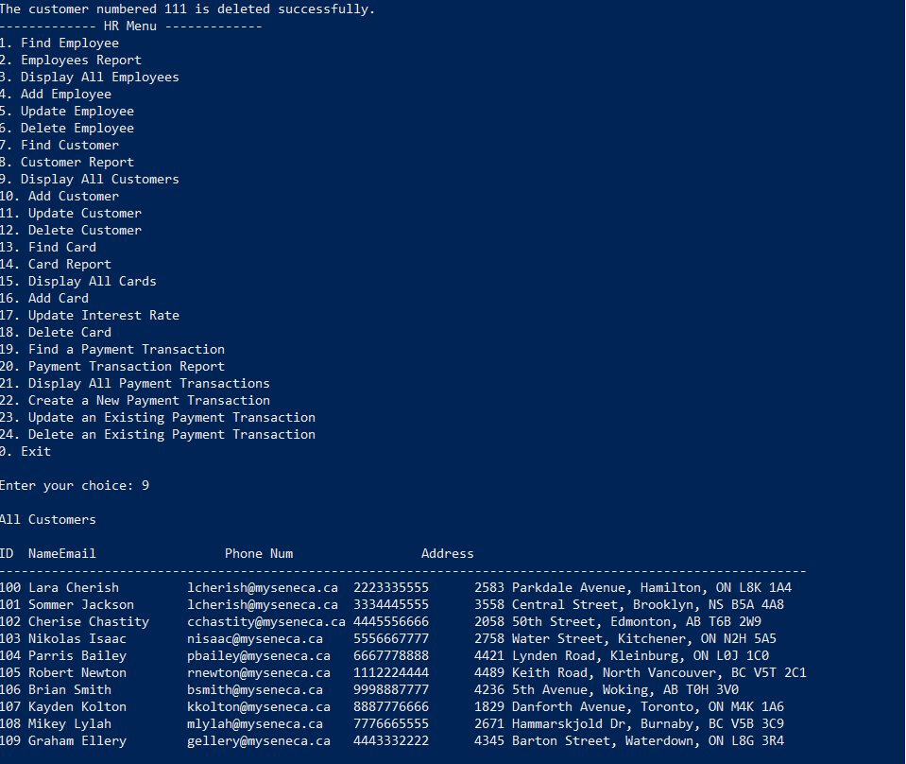

Payment Transaction Functions (Stephen Suresh ID: 117916213):

Find Payment:

Display Payment:

Display All Payments:

Insert New Payment

Update a Payment Transaction

Delete a Payment Transaction

